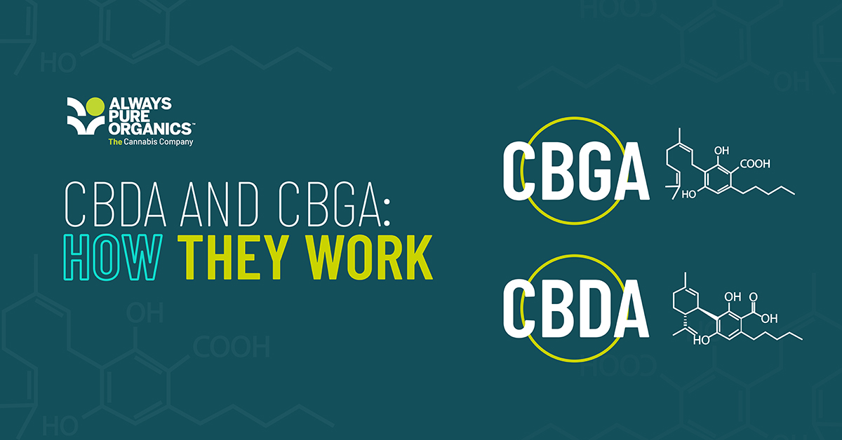
CBDA & CBGA: How They Work

The brain's reward system for cannabinoid compounds

Always Pure Organics are excited to share our latest research on the benefits and potential breakthroughs that are coming from understanding how cannabinoid compounds break down and can be used to solve human needs.

There is a complex chemical pathway through which cannabinoid compounds are produced from the Cannabis plant. Cannabinoid compounds don’t appear within the Cannabis plant fully formed, the process involves many precursor molecules and enzymes. Contrary to popular belief, THC and CBD are not derived from CBG, despite its moniker as ‘the mother of all cannabinoids’. Instead, the two major cannabinoids are synthesised from cannabigerolic acid (CBGa), CBG’s acid precursor.

Essentially, the plant produces cannabinoid acids which are then converted via enzymes into other acid compounds, THCa and CBDa in this case. Over time, the acid compounds naturally degrade into the neutral forms that we are all familiar with, which are THC and CBD. The acid forms are naturally reactive (as is the case for all acids) and are typically found in low concentrations in harvested plants because of this.

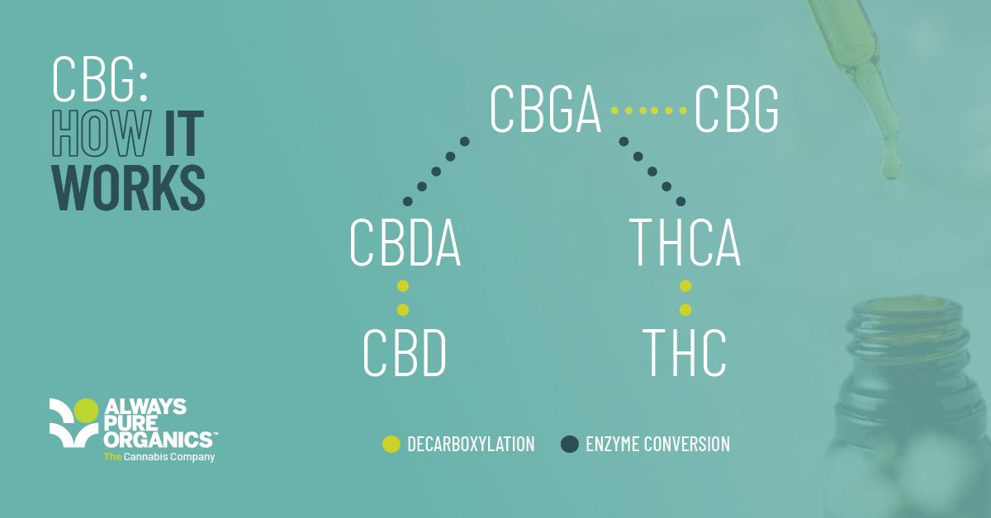

This scarcity within the plant explains in part why there has been relatively little research carried out investigating the effects of CBDa and CBGa compared to THC and CBD. A recent review of literature for CBDa by Formato et al. (2020) found only 104 results on PubMed compared to almost 3000 for CBD, for example. One interesting potential application is in the use of CBGa and CBDa to mitigate infection of human cells with SARS-CoV-2 (van Breeman et al. 2021). van Breeman found that CBDa and CBGa were effective inhibitors of the spike protein’s ability to bind to cells.

While still experimental in nature, the possible ability of acidic cannabinoids to help treat and prevent Covid-19 would be invaluable in current global circumstances, especially since Covid-19 is likely to become endemic in a similar manner to the flu virus.

Therapeutic potential for the treatment of Covid-19 is not the only activity these compounds share. A paper by Dawidowicz et al. (2021) demonstrated the antioxidant properties of a range of cannabinoids and cannabinoid acids compared to Vitamin E. While there was some variance, they concluded that each compound was roughly equivalent in efficacy to Vitamin E overall. The antioxidant properties of the neutral cannabinoids have been reasonably well-established, but this is a new discovery for the acid forms. If it can be properly quantified and proven through clinical trials, these compounds could prove to be useful ingredients in products like cosmetics, as they often benefit from the inclusion of antioxidants in their formulation.

CBDa specifically has been shown to demonstrate a range of effects similar to CBD such as anti-inflammatory and anti-convulsant. One area in which CBDa outperforms its neutral form, however, is in the prevention of vomiting (anti-emesis). Bolognini et al. (2012) demonstrated that CBDa inhibits vomiting in rats and reduces the magnitude of anticipatory nausea reactions. Anticipatory (or learned) nausea is where nausea or vomiting is induced by certain triggers, for example in chemotherapy patients. If a person vomits every time they go through a session of chemotherapy, they will become conditioned to feel nauseated before even receiving the treatment (Roscoe et al, 2012). CBDa’s ability to attenuate this reaction could prove to be immensely beneficial, as current treatment for this is lacking.
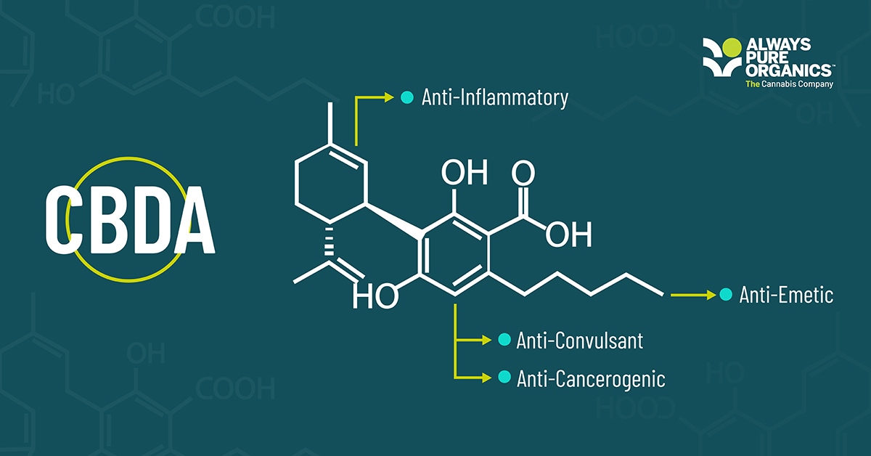
CBGa has not been the subject of much research, turning up a scant 83 results on the literature database PubMed. This means that the potential of this compound has yet to be properly determined and it’s likely that over time it will demonstrate a similar wide range of effects to the other cannabinoids. In a 2021 paper by Anderson et al., CBGa – at low dosages - demonstrated anti-convulsant properties in mice that had seizures induced via high temperature, similar to how seizures from Dravet’s syndrome occur. This work expands upon the knowledge of CBD medicines such as Epidiolex that have proven anti-epileptic effects. It’s possible that we may see amendments or additions to anti-epilepsy treatments that include CBGa or other cannabinoids.

While CBDa and CBGa are less well known than their neutral counterparts, they are still members of the same chemical family and demonstrate the same potential for a wide range of useful effects. The current state of literature might still be lacking, but with the increased interest in cannabinoids, continual relaxation in regulations surrounding their use and improvements in public opinion towards Cannabis extracts, it’s likely that research will begin to increase as the possible benefits of these compounds are made clearer and easier to access. CBDa and CBGa are likely to be the next step in developing our understanding of the full potential of the Cannabis plant.

We continue to invest in studies, research and utilising our inhouse Science team for new product development. As ever, we are being driven by our value to make lives better through health, wellness and mindset.

References

Anderson et al. (2021) Cannabigerolic acid, a major biosynthetic precursor molecule in cannabis, exhibits divergent effects on seizures in mouse models of epilepsy, British Journal of Pharmacology, 178, 4826-4841

Bolognini et al. (2012) Cannabidiolic acid prevents vomiting in Suncus murinus and nausea-induced behaviour in rats by enhancing 5-HT1A receptor activation, British Journal of Pharmacology, 168, 1456-1470

Dawidowicz et al. (2021) CBG, CBD, Δ9-THC, CBN, CBGA, CBDA and Δ9-THCA as antioxidant agents and their intervention abilities in antioxidant action, Fitoterapia, 152, 104915

Formato et al. (2020) (‒)-Cannabidiolic Acid, a Still Overlooked Bioactive Compound: An Introductory Review and Preliminary Research, Molecules, 25(11), 2638

Roscoe et al. (2010) Anticipatory Nausea and Vomiting, Supportive Care in Cancer, 19, 1533-1538
van Breeman et al. (2021) Cannabinoids Block Cellular Entry of SARS-CoV-2 and the Emerging Variants, doi: 10.1021/acs.jnatprod.1c00946, EPub ahead of print. Accessed 20/01/22.

To find out more about how Always Pure Organics can support your business on its CBDjourney, or to discuss our bespoke formulations, email info@alwayspureorganics.com , visitalwayspureorganics.com, call us on (+44) 0800 9991562, or follow us on LinkedIn, YouTube and Instagram

